Project Design Phase-II
Data Flow Diagram & User Stories

Date | 11 September 2026
Project Name | Laptop Request Management System
Maximum Marks | 4 Marks

Data Flow Diagrams:
A Data Flow Diagram (DFD) is a traditional visual representation of the information flows within a system. A neat and clear DFD can depict the right amount of the system requirement graphically. It shows how data enters and leaves the system, what changes the information, and where data is stored.

Example: (Simplified)
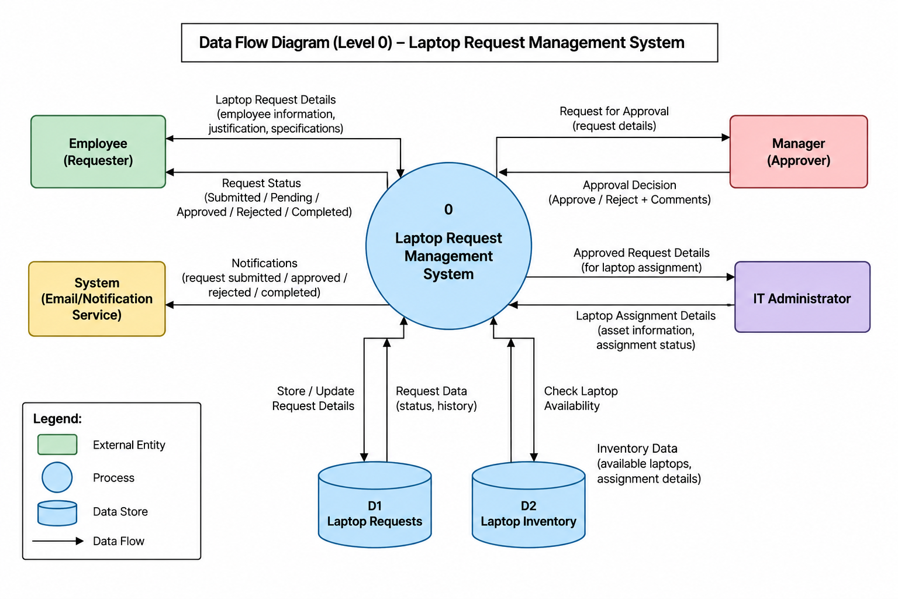

User Stories
User Type | Functional Requirement (Epic) | User Story Number | User Story / Task | Acceptance criteria | Priority | Release
Customer (Employee) | Laptop Request | USN-1 | As an employee, I want to submit a laptop request with the required details so that I can receive a laptop for my work. | Employee can submit the laptop request successfully with all mandatory details. | High | Sprint-1
Customer (Employee) | Request Tracking | USN-2 | As an employee, I want to view my laptop request status so that I know whether it is pending, approved, rejected, or completed. | Employee can view the current status of the submitted request. | High | Sprint-1
Manager / Approver | Request Approval | USN-3 | As a manager, I want to review laptop requests so that I can approve or reject them. | Manager can approve or reject a request and provide comments. | High | Sprint-1
IT Administrator | Laptop Assignment | USN-4 | As an IT administrator, I want to check laptop availability and assign an available laptop to an approved employee. | IT administrator can view available laptops and assign one to an approved request. | High | Sprint-2
IT Administrator | Notifications | USN-5 | As an IT administrator, I want the system to send notifications when the request status changes. | Appropriate notification is generated when a request is approved, rejected, or completed. | Medium | Sprint-2
IT Administrator | Laptop Inventory | USN-6 | As an IT administrator, I want to maintain laptop inventory details so that I can track available and assigned laptops. | IT administrator can view and update laptop inventory and assignment information. | High | Sprint-2

